
BODA BODA SACCO SAVINGS MANAGEMENT SYSTEM

SYSTEM DOCUMENTATION
SUBMITTED BY,
CHARLES MBURU
DIT-01-0157/2025

A SYSTEM DOCUMENTATION SUBMITTED IN PARTIAL FULFILMENT FOR THE AWARD OF DIPLOMA IN INFORMATION TECHNOLOGY BY ZETECH UNIVERSITY
APRIL 2025

DECLARATION
I declare that this project Boda Boda SACCO Savings Management System is my original work and has not been submitted to any other institution for academic grading. The work presented in this documentation has been carried out by me and has not been copied from any other source except where duly acknowledged.
Student Name: ____________________________ Sign: _________________ Date: __________
Supervisor Name: _________________________ Sign: _________________ Date: __________

DEDICATION
I dedicate this project to my family for their continuous support, encouragement, and understanding throughout my academic journey. I also dedicate it to my lecturers and mentors who guided me and contributed to the successful completion of this project.

ABSTRACT
This project presents the development of a Boda Boda SACCO Savings Management System aimed at improving efficiency, transparency, and accountability in SACCO operations. The system was developed over the course of the project period using web-based technologies including HTML, CSS, JavaScript, PHP, and MySQL database.
The main purpose of the system is to address challenges faced by SACCOS such as poor record-keeping, lack of transparency, and inefficiencies associated with manual systems. The system provides functionalities such as member registration, savings tracking, loan management, and report generation.
Through the implementation of this system, SACCO operations can be automated, reducing errors, improving data security, and enabling better financial decision-making. The project successfully achieved its objectives by delivering a functional and user-friendly system that enhances service delivery within SACCO organizations.

DEFINITION OF KEY TERMS
Database: A structured collection of data stored electronically for easy access, management, and updating.
Frontend: The part of a system that users interact with directly, including web pages and user interfaces.
Backend: The server-side part of a system responsible for processing data and managing the database.
Loan: Money borrowed by a member from the SACCO with an agreement to repay with interest.
Member: A registered individual in the SACCO who can make contributions and access services.
SACCO: Savings and Credit Cooperative Organization that provides financial services.
System: A collection of components that work together to achieve a specific goal.
Transaction: Any financial activity such as deposits, withdrawals, or loan repayments recorded in the system.
User Interface: The visual part of the system through which users interact with the application.

ABBREVIATIONS AND ACRONYMS
CSS – Cascading Style Sheets
DBMS – Database Management System
HTML – HyperText Markup Language
IDE – Integrated Development Environment
JS – JavaScript
PHP – Hypertext Preprocessor
SACCO – Savings and Credit Cooperative Organization
SQL – Structured Query Language
UI – User Interface
UAT – User Acceptance Testing

LIST OF FIGURES
Fig 2.2.1 Login Page Design
Fig 2.2.2 Member Registration Form
Fig 2.2.3 Savings Contribution Recording Page
Fig 2.2.4 Loan Processing Interface
Fig 2.2.5 Loan Repayment Recording Page
Fig 2.2.6 Accounts Records and Reports Page
Fig 2.3.1 Login Process Flowchart
Fig 2.3.2 Member Registration Flowchart
Fig 2.3.3 Savings Contribution Flowchart
Fig 2.3.4 Loan Processing Flowchart
Fig 2.3.5 Loan Repayment Flowchart
Fig 2.4.1 Data Flow Diagram (DFD)
Fig 3.2.1 Login Page Interface
Fig 3.2.2 Login Page Code
Fig 3.2.3 Registration Form Interface
Fig 3.2.4 Dashboard Interface
Fig 3.2.5 Contributions Page
Fig 3.2.6 Reports Page
Fig 3.3.1 Login Validation Code
Fig 3.3.2 Registration Logic Code
Fig 3.3.3 Contribution Processing Code
Fig 3.3.4 Loan Management Code

LIST OF TABLES
Table 1.4 Functional Requirements
Table 1.6 Project Schedule Breakdown

TABLE OF CONTENTS
DECLARATION I
DEDICATION II
ABSTRACT III
DEFINITION OF KEY TERMS IV
ABBREVIATIONS AND ACRONYMS V
LIST OF FIGURES VI
LIST OF TABLES VII
TABLE OF CONTENTS VIII
CHAPTER ONE: PROJECT PLANNING AND ANALYSIS 1
1.1 Statement of Problem 1
1.2 System Objectives 2
1.2.1 General Objective 2
1.2.2 Specific Objectives 2
1.3 Functional Requirements 3
Table 1.5 Project Schedule Breakdown 6
CHAPTER TWO: DESIGN AND MODELING 7
2.1 Preface to Modelling 7
2.2 Interface Models 7
2.2.1LoginPage Design 7
2.2.2MemberRegistration Form 7
2.3 DesignModels 11
2.3.1 LoginProcess Flowchart 11
2.3.5 Loan Processing Flowchart 13
2.3.6 Loan Prepayment Flowchart 14
2.4 Data Flow Diagram( DFD) 15
CHAPTER THREE: SYSTEM IMPLEMENTATION 17
3.1 Introduction 17
3.2 User Interface Development 17
3.2.1 Login Page Development 17
3.2.2 Registration Page Development 18
3.2.3 Dashboard Development 19
3.2.4 Contributions Page 20
3.2.5 Reports Page 20
3.3 Logic Development 21
3.3.1 Login Validation Logic 21
3.3.2 Member Registration Logic 21
3.3.3 Contribution Processing Logic 22
3.3.4 Loan Management Logic 23
3.4 Testing 24
3.5 Deployment 25
CHAPTER FOUR: CONCLUSION AND RECOMMENDATION 26
4.1 Conclusion 26
4.2 Recommendation 26
REFERENCES 28

CHAPTER ONE: PROJECT PLANNING AND ANALYSIS
  - Statement of Problem
The boda boda transport sector is a major source of employment and income for many low- and middle-income earners in Kenya. To improve financial security, boda boda operators often form Savings and Credit Cooperative Organizations (SACCOs) to mobilize savings, access loans, and provide social support. For example, boda boda groups established SACCOs around 2020 to empower members economically and help them cope with emergencies and low incomes (Science Africa, 2020). (Science Africa)
Despite their importance, many boda boda SACCOs rely on manual or poorly coordinated systems to manage member registration, savings contributions, loan records, and financial reporting. Such approaches are inefficient, error prone, and vulnerable to fraud and data loss. Weak internal controls and inadequate oversight mechanisms in SACCO operations have been identified as major governance challenges, leading to mismanagement of funds and erosion of member trust (SACCO Trend, 2020). (Sacco Trend Magazine)
Poor record-keeping and lack of transparency complicates financial management. Without accurate and timely records, SACCO leaders struggle to monitor members’ savings balances, loan repayments, and overall financial performance. This situation can result in delayed services, disputes among members, and difficulty in making informed financial decisions. Mismanagement and weak accountability systems may also expose members’ funds to unauthorized use or loss (Sacco Champions, 2020). (Kenya Sacco Champions)
Additionally, the absence of modern technological systems limits operational efficiency and scalability. Many SACCOs lack the resources or expertise to adopt digital solutions, forcing them to depend on outdated manual processes. Such systems cannot support real-time reporting, secure data storage, or effective financial planning, which are essential for sustainable growth (Mondato, 2020). (Mondato Insight)
Therefore, there is a critical need for a BodaBoda SACCO Savings Management System that can automate member management, savings tracking, loan processing, and financial reporting. Implementing a reliable computerized system would enhance transparency, reduce fraud and errors, improve service delivery, and support sound decision-making for the long-term sustainability of boda boda SACCO.

1.2 System Objectives

1.2.1 General Objective
To develop a website that will increase transparency and automate the SACCO savings account operation.

1.2.2 Specific Objectives
- To analyze the existing manual data input and record-keeping process in order to identify challenges related to accuracy, transparency, and member payment contributions.
- To design a user- friendly information system for managing contributions, savings and loans.
- To implement a secure database system that stores and synchronizes member information and transactions history.
- To automate payment calculations and generate reports.

1.3 Functional Requirements
User | User Activities | Features
System administrator | - Create and manage user accounts  - Assign roles and permission  - Backup and secure data | - User management module  - Role based access control  - Data backup and security tools
Sacco admin | - Register members  - Record contributions  - Approve loans | - members registration module  - Digital self registration entry form  - Loan Disbursement Module
Members | -View account transaction history  - Check payment status  - Confirm records | -contributions tab  - Payment status tracking  - Read-only access to records
Finance officer/treasurer | -Review transacion records  _ Calculate and approve loans  - Generate finance reports | - Payment verification interface  - Payment approval module  - Financial reporting feature
1.3 Functional Requirements Table

1.4 Breakdown of tools and resources to be used

Tool and resources | purpose
Laptop  Processor: Intel core i5 or equivalent  RAM: minimum 6GB  Storage: minimum 250GB HDD or SSD  Operating system:windows 10 or latest | For system development,testing and documentation
Front-end  HTML  CSS | -To design system pages and data entry forms  -To style the system and improve user interface appearance
Back-end  PostgreSQL | - To store member information details,contribution details,payments and loan records
Integrated development environment (IDE)  Visual studio code  Notepad++ | -To write and edit HTML ,CSS and back-end files
Internet connectivity  Speed:minimum 5mbps | -For downloading development tools,learning resources and system updates
Web browser(Google chrome/microsoft edge) | -To access,test and run the system

 | PROJECT MILESTONES
WEEKS | Project Planning & Analysis  (System Documentation: Coverpage & Chapter One) | Project Design & Modeling  (System Documentation Chapter Two) | Project Development & Testing  (System Documentation Chapter Three) | Project Deployment  (System Documentation Chapter Three) | Final Touches of System Documentation  (Preliminary Pages, Chapter Four & References) | Project Presentation
5-9 jan
12-16 jan
19-23 jan
26-30 jan
2-6 feb
9-13 feb
16-20 feb
23-27 feb
30-4 mar
7-11 mar
14-18mar
21-25mar

Table 1.5 Project Schedule Breakdown

CHAPTER TWO: DESIGN AND MODELING

2.1 Preface to Modelling
This chapter presents the design and modelling phase of the digital system developed for enhancing record keeping in a Boda Boda SACCO. The system is intended to strengthen transparency, track loan records and member data.
System modelling was carried out before the development phase to help visualize how the system would operate, how members would interact with it, and how SACCO data would be reused, stored,and recaptured.This modelling stage assured that all SACCO operations were well understood and represented.The modelling process helped in understanding system conditions, minimizing errors during development, and icing responsibility records.Flowcharts, and data flow diagrams were used to plan an effective system that supports accurate member enrollment , automated savings tracking, loan operation and dependable report generation.

2.2 Interface Models

2.2.1 LoginPage Design
The login page allows authorized users similar as the SACCO treasurer, admin and members to access the system using a username and password. This design ensures system security, controlled access, and protects sensitive SACCO information.
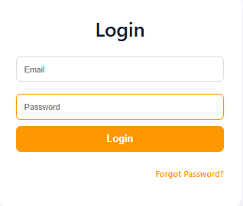fig 2.2.1 login page design

2.2.2 MemberRegistration Form
This form allows new Boda Boda SACCO members to be registered into the system. It captures important member details such as fullname,ID number, phone number, motorcycle enrollment details, class number, and enrollment date. This information enables proper savings
contributions and loan eligibility.
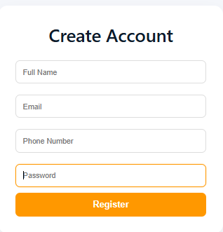fig 2.2.2 member registration form
2.2.3 Savings ContributionRecording Page Design
This interface is used to record savings made by members on a daily,weekly,monthly,quarterly or yearly basis depending on
SACCO policy. It also allows the treasurer to record
contribution amount,contriution date,Payment system( cash/ mobile money/ bank) and payment reference number.
This interface enables SACCO members to apply for loans and allows SACCO officers to review,authorize, or reject loan requests. The interface captures loan details similar as loan amount,prepayment period, interest rate.
The system also helps automate
- Loan eligibility checking
- Loan balance computations
- Prepayment schedules

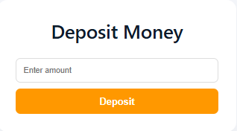22.2.4 savings contribution recording page
2.2.4 Loan Prepayment Recording Page Design
This interface is used to record loan disbursements made by members. It improves delicacy by automatically stream lining the remaining loan balance and shadowing prepayment history.
Prepayment details recorded include
- Amount paid
- Date of payment
- Payment system
- Loan account reference
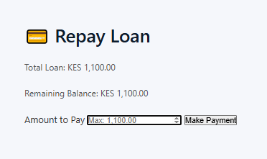
2.2.5 loan prepayment recording page design
2.2.5 Accounts Records
This interface displays summaries of SACCO fiscal records such as
- Total member savings
- Loan disbursements
- Outstanding loan balances
- Member contribution statements
- Loan prepayment reports
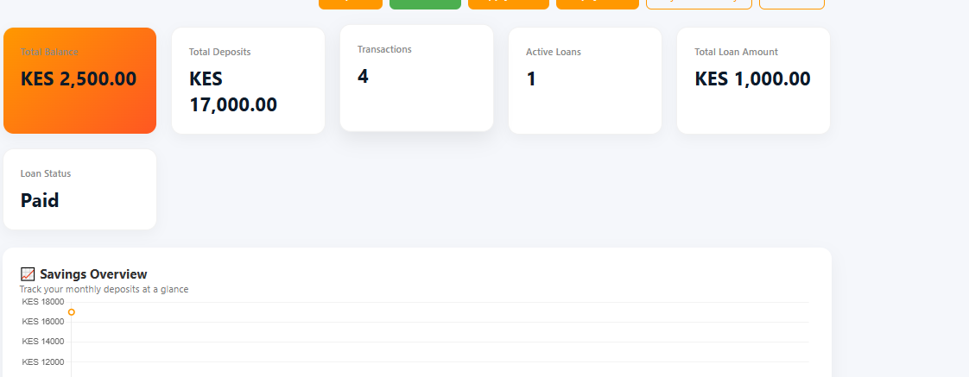2.2.5 Accounts Records andReports Page Design

2.3 DesignModels

2.3.1 LoginProcess Flowchart
This flowchart illustrates the way followed when a member attempts to access the system. It includes confirmation of username and password,and granting access to authorized members.

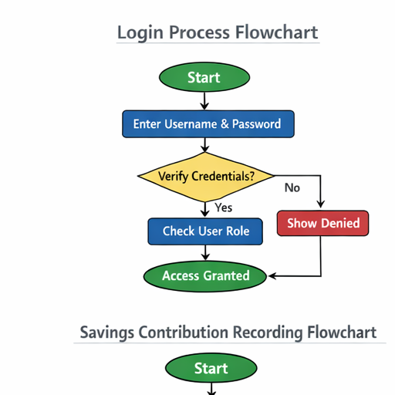2.3.1 login process flowchart
2.3.2 Member Registration Process Flowchart
This flowchart shows the way followed when registering a new SACCO member. It includes entering member details, validating needed fields,and saving the information into the system database.
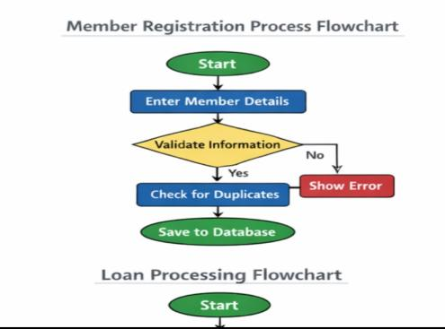2.3.2 Member registration process flowchart.
2.3.4 Savings Contribution Recording Flowchart
This flowchart explains how member savings are recorded. It shows the process of opting a member, entering contribution details and member’s savings balance automatically.
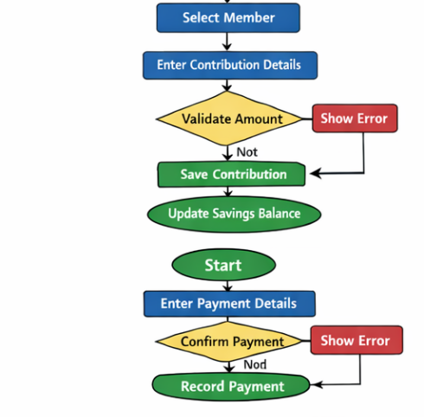2.3.4 saving contribution recording flowchart

2.3.5 Loan Processing Flowchart
This flowchart presents the step- by- step process showing how loans are handled within the SACCO.
It includes loan operation, eligibility verification and disbursement recording, and streamlining the member’s loan account.
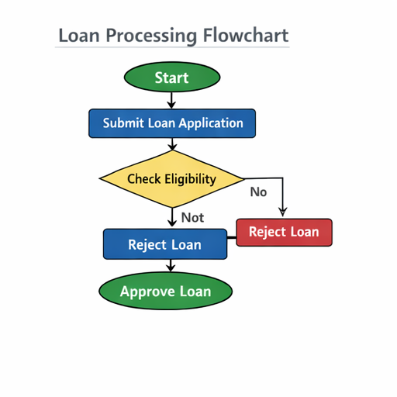2.3.5 loan processing flowchart

2.3.6 Loan Prepayment Flowchart
This flowchart shows how loan disbursements are recorded and how the system updates loan balances.
It includes prepayment entry, confirmation, streamlining balances, and generating prepayment history.
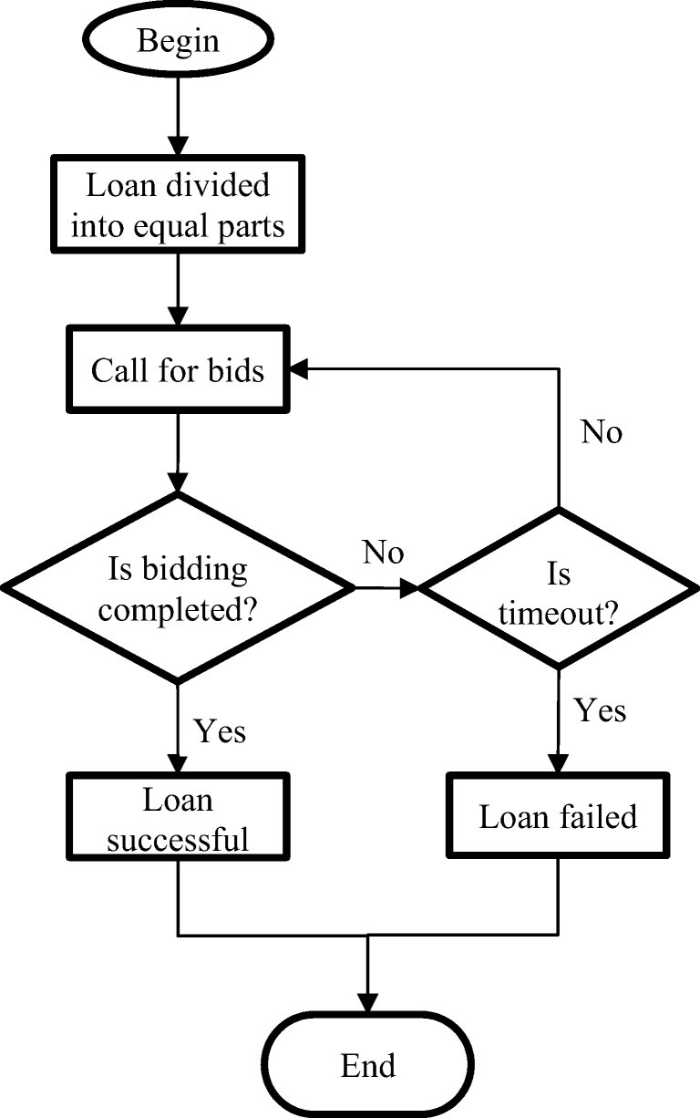2.3.6 loan prepayment flowchart

2.4 Data Flow Diagram( DFD)
The data inflow illustration shows how data moves within the system from member enrollment and
savings entry to loan processing, prepayment recording, and report generation. It illustrates how data is
captured, reused, stored in the database, and presented as reports for SACCO officers and members.
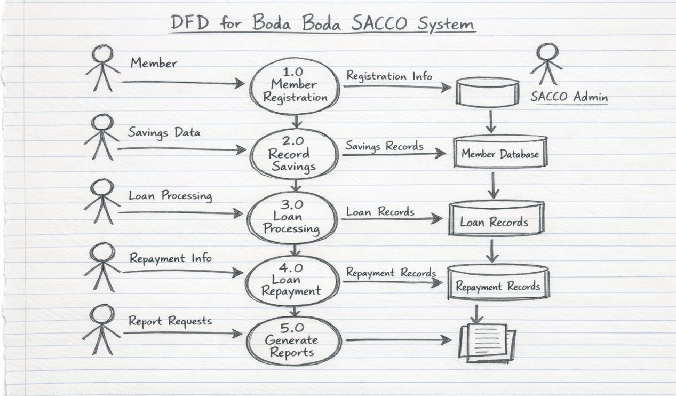2.4.1 dfd diagram

CHAPTER THREE: SYSTEM IMPLEMENTATION
(DEVELOPMENT, TESTING AND DEPLOYMENT)

3.1 Introduction
This chapter presents the implementation phase of the Boda Boda SACCO Management System. It explains how the system was developed, the tools and technologies used, system requirements, and how different components were integrated to form a fully functional system. The implementation phase transforms the system design into a working application that meets user requirements such as member management, savings tracking, loan processing, and report generation.

3.2 User Interface Development

3.2.1 Login Page Development
The login page allows registered users to securely access the system using their credentials (email and password).
Features:
- Input fields for username/email and password
- Login button
- Error message for invalid login
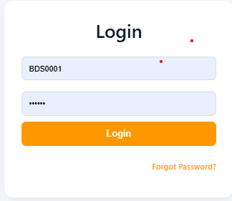Fig 3.2.1 Login Page Interface
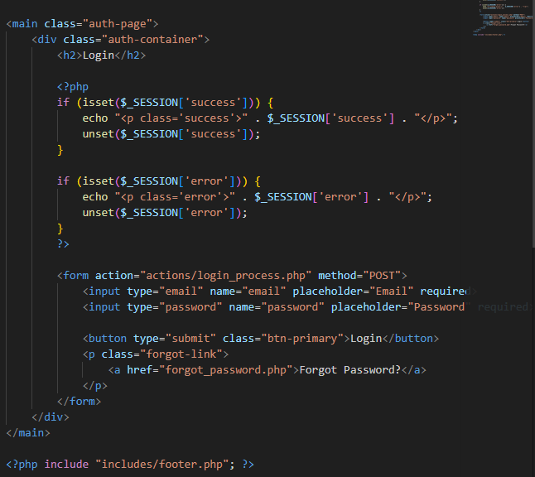Fig 3.2.1.2 Login Page HTML Code

3.2.2 Registration Page Development
This page enables SACCO administrators to register new members into the system.
Features:
- Input fields for member details (name,Email, phone number, password)
- Submit button
- Data validation
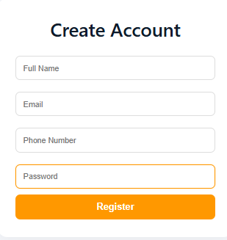Fig 3.2.2 Member Registration Form

3.2.3 Dashboard Development
The dashboard provides an overview of system activities such as total members, total savings, and loan status.
Features:
- Summary cards (members, savings, loans)
- Navigation menu
- Quick access links
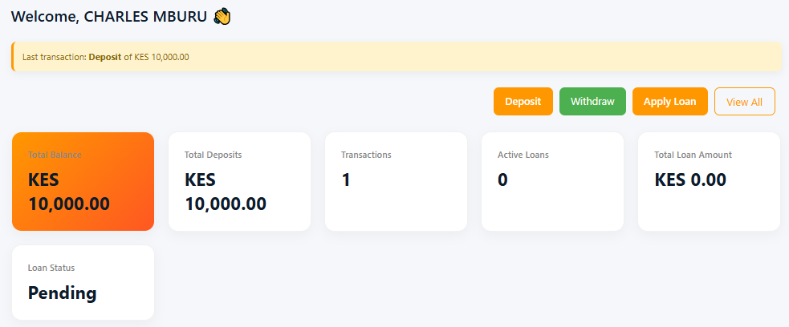Fig 3.2.3 System Dashboard

3.2.4 Contributions Page
This page allows recording and viewing member contributions.
Features:
- Deposit entry form
- Contributions table
- Search/filter option
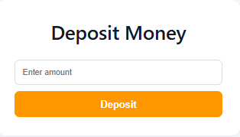Fig 3.2.4 Contributions Interface

3.2.5 Reports Page
This page generates financial reports for decision-making.
Features:
- Member statements
- Loan reports
- Savings summaries
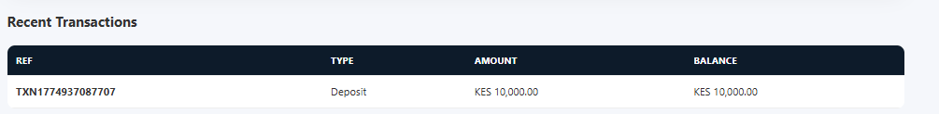Fig 3.2.5 Reports Interface

3.3 Logic Development
The system logic was implemented using PHP and JavaScript to handle backend processing and user interactions.

3.3.1 Login Validation Logic
The system validates user credentials by checking the database.
Process:
- User inputs credentials
- Data is sent to server
- System checks database
- Access granted or denied
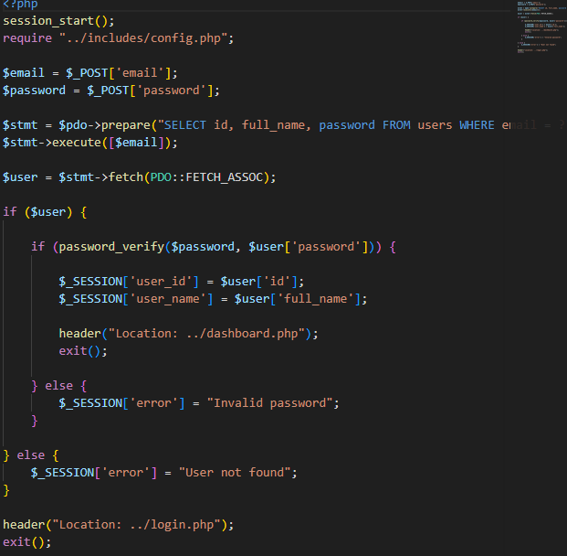Fig 3.3.1 Login Validation Code

3.3.2 Member Registration Logic
Handles storing new member data into the database.
Process:
- Capture form data
- Validate inputs
- Insert into database
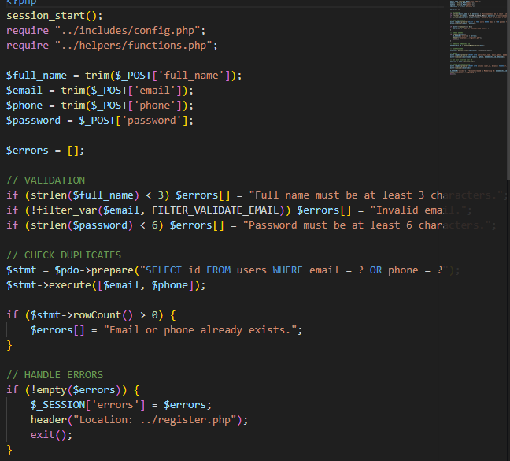Fig 3.3.2 Registration Logic Code

3.3.3 Contribution Processing Logic
Records member deposits and updates balances.
Process:
- Input contribution amount
- Save transaction
- Update total savings
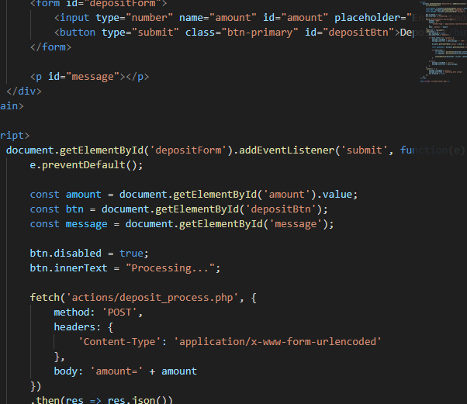Fig 3.3.3 Contribution Processing Code

3.3.4 Loan Management Logic
Handles loan application, approval, and repayment tracking.
Process:
- Member applies for loan
- Admin reviews application
- Loan approved/rejected
- Repayments tracked
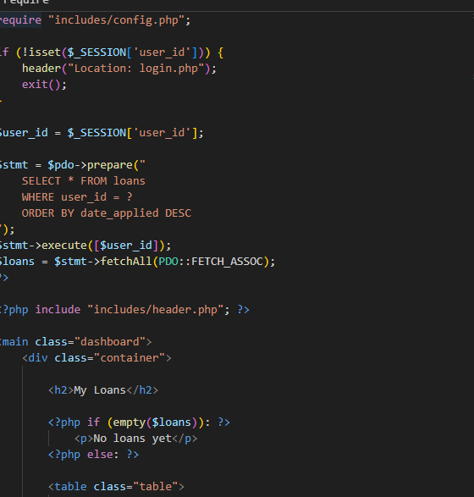Fig 3.3.4 Loan Management Code

3.4 Testing
System testing was conducted to ensure all modules function correctly and meet user requirements.
Types of Testing Conducted:
- Unit Testing:
Individual modules such as login, registration, and contributions were tested separately.
- Integration Testing:
Ensured modules work together correctly, e.g., registration linking with database.
- System Testing:
The complete system was tested as a whole to ensure proper functionality.
- User Acceptance Testing (UAT):
Sample users tested the system to confirm usability and functionality.
All modules performed as expected after fixing minor errors such as form validation and styling inconsistencies.

3.5 Deployment
The system was deployed locally using XAMPP server.
Deployment Steps:
Installed XAMPP server
- Started Apache and MySQL services
- Created database using phpMyAdmin
- Imported database tables
- Placed system files in htdocs folder
- Configured database connection (sacco_db.php)
- Accessed system via browser using localhost
System Path:
localhost/BodaSacco/index.php

CHAPTER FOUR: CONCLUSION AND RECOMMENDATION

4.1 Conclusion
This project focused on the development of a Boda Boda SACCO Savings Management System aimed at improving efficiency, transparency, and accountability in SACCO operations.
In Chapter One, the project identified challenges faced by SACCOs such as poor record-keeping, lack of transparency, and inefficiencies in manual systems. Objectives were defined to address these challenges through automation.
Chapter Two presented system designs and models including user interface designs and system logic diagrams, which helped in visualizing the system before development.Chapter Three explained how the system was implemented using technologies such as HTML, CSS, JavaScript, PHP, and MySQL. It also covered testing and deployment processes to ensure the system operates effectively.
Through this project, several skills were acquired including web development, database design, debugging, and system testing. Challenges encountered included database connection errors, UI design issues, and integrating frontend with backend, which were resolved through research and practice.

4.2 Recommendation
The developed system is functional; however, several improvements can be made to enhance its performance and usability:
- Integration with Mobile Money (M-Pesa/Airtel money):
Future developers should integrate payment systems such as Airtel money to allow real-time contributions and loan repayments.
- Cloud-Based Deployment:
Instead of local hosting, the system can be deployed on cloud servers to allow remote access from anywhere.
- Mobile Application Development:
A mobile app version of the system can improve accessibility for SACCO members.
- Enhanced Security Features:
Implement advanced security measures such as encryption, two-factor authentication, and secure APIs.
- Biometric Authentication:
Replace manual login with biometric verification for better security. eg (fingerprint or facial recognition)
- Automated Notifications:
Add SMS or email notifications for transactions, loan approvals, and reminders.
These improvements would enhance system efficiency, security, and user experience.

REFERENCES
Kenya Sacco Champions. (2020). Challenges facing SACCO financial management. https://www.kenyasacco.com
Mondato Insight. (2020). Digital transformation in SACCOs and financial institutions. https://www.mondato.com
Sacco Trend Magazine. (2020). Governance challenges in SACCO operations. https://www.saccotrend.co.ke
Science Africa. (2020). Growth of boda boda SACCOs in Kenya. https://www.scienceafrica.co.ke
s

